Identifying different soil types

What are the main soil types found in Ireland and where are they found?
Name an (a) Igneous rock
(b) Metamorphic rock
(c) Sedimentary rock
Describe Frost (onion) weathering
What biological factors cause Physical weathering
What are the 3 types of Chemical weathering?
Give an example of a landscape undergoing Carbonation
Describe soil structure
What is humus?
What is soil texture?
What affects the properties of soil?
How does soil pore size effect water retention?
What is capillarity?

Materials
2-3 Retort stands
Water trough
Plastic pipes Cress seeds Cotton wool Sponges
Muslin cloth Rubber bands Soil samples Water

Protocol
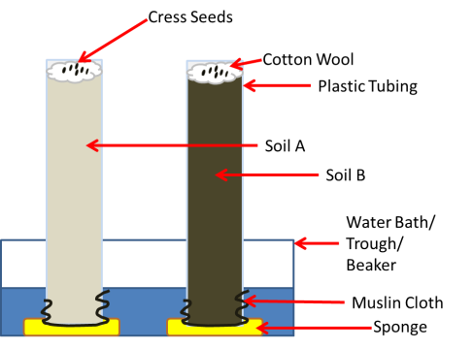
- Secure muslin cloth around the bottom of the tubes using the rubber band. This will stop soil from falling out when filling the tube later.
- Fill each tube with either Soil A or Soil B (or your own Soil C) and label the tubes accordingly.
- Fill the water trough with approx. 2-3 inches of water
- Place sponges at the bottom of the trough and position the tubes above each sponge. The sponge will make a constant supply of water available to each tube. A retort stand will be required to keep the tubes in an upright position.
- Place equal amounts of cotton wool at the top of each tube of soil and gently pat down.
- Add an equal number of cress seeds to the cotton wool
- Place the set up on an even surface where it will not be disturbed
- Over the next couple of day’s record whether or not the seeds germinate and in which soil sample they germinate first.

