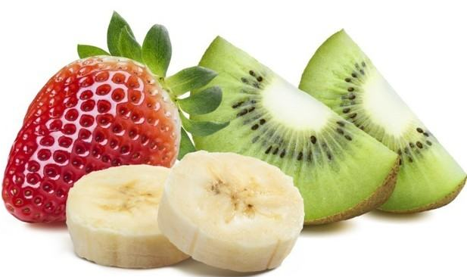
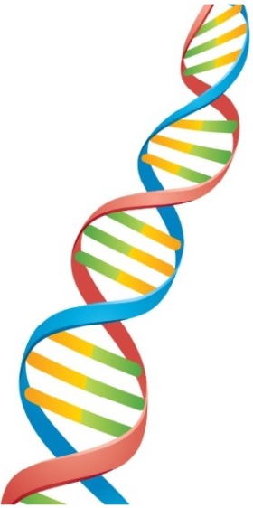

If you plan to carry out this experiment, please read the below instructions carefully and plan the experiment before starting the DNA extraction process.
DNA extraction from fruit
DNA is the hereditary material present in all cells.
The experiment described here will allow you to isolate DNA from fruit.
To carry out the DNA extraction, you will need:
- Fruits – Kiwi, Strawberries, Banana or any soft ripen fruit (all work well)
- Washing up liquid, Table salt, Tap water
- Rubbing alcohol (you can get it from pharmacy shop)
- Chopstick or toothpick
- Clear glasses or test tubes
- A medium size bowl and a fork
- Sieve (optional)

Before you begin: This is a very important first step
- Make sure you have chilled the alcohol in the freezer.
- Room temperature alcohol may not work nearly as well as cold alcohol.
- Pop the whole container in the freezer to chill it.
- The alcohol will not actually freeze!
Prepare fruit mush:
- Any ripen fruit will work well.
- Make sure that you remove skin of fruits like banana or kiwi.
- Use either 1/3 banana, 1 kiwi or 2 strawberries. You don’t need too much of fruit.
- Mash up the fruit of your choice in a bowl. Use a fork, it helps.
Add the extraction solution to the fruit mush:
- In a clean glass, mix around ~80 ml of water, half teaspoon of salt and two teaspoons of washing up liquid and stir gently avoiding making too many bubbles.
- Add this extraction solution to the fruit mush and leave at room temperature for 10 minutes. Detergent breaks the cell membrane & Salt removes proteins.
- Optional step: You can sieve the above solution to remove pulp and seeds. This gives you a clear solution for DNA precipitation.

Precipitating the DNA:
- Remove the alcohol from the freezer and carefully pour the alcohol down the side of the glass.
- You need about equal volumes of DNA solution to alcohol.
Visualise the DNA:
- After around 10 minutes, you should be able to see a mass of white stringy material floating at the top of the tube/glass. This is the DNA from the fruit you have used.
- You can fish this DNA out using the chopstick/toothpick and place it onto a piece of card to take home.

Observations to record
- Look at each step of the protocol. What are the different steps and reagents (washing-up liquid, salt, water, alcohol) used for in the experiment?
- How are you able to see the DNA?
- Do you think that the sample you have prepared is “pure DNA”?

